Homework 7

Nathalie Kwamo

1. a. Watch video and create your AWS Windows 2019 EC2 instance

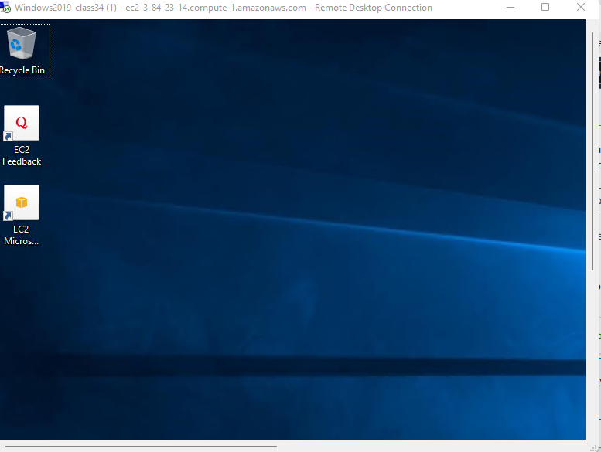

b. Configure file and print sharing on your Win10pro VM

Directions to follow:

1. Enable file and print on the Win10pro NOS:

-Right click on network icon in Win10pro NOS

-Double click on network and sharing center

-click on change advanced sharing settings

-click on the arrow pointing down next to all networks

-Turn on sharing and select turn off password protected sharing

-click on save changes and close the page

1. Create a share (create and share a folder ):

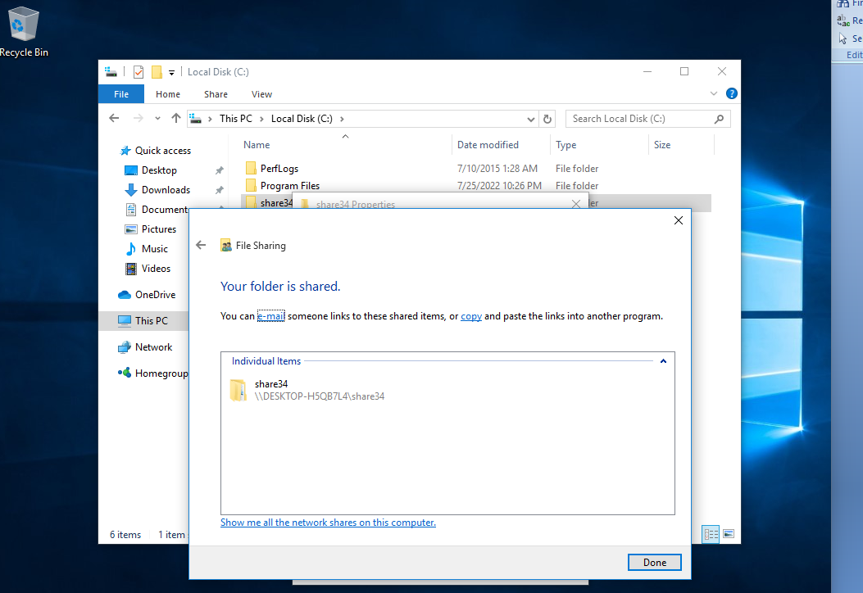

To create a share:

-Click on your library folder

-Click on this PC

-Double click on your C: Drive

To create a folder:

-Right click on blank spot on the page-click on new-folder-type-share34, and then folder is created.

1. Map to the share from your laptop

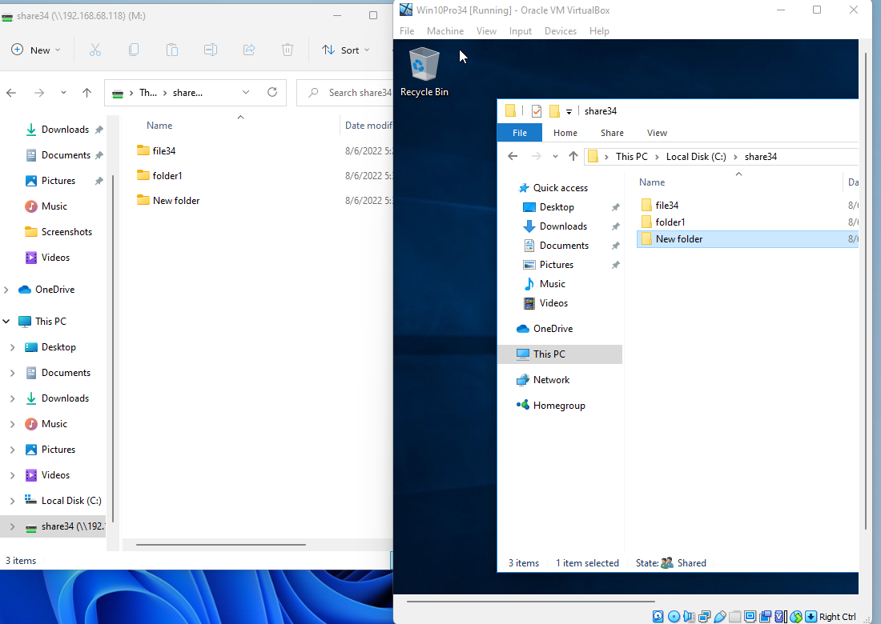

To map a network drive:

-Display the share

-Right click on the folder you are to map

-Select Map network drive

-Select M: drive and click reconnect at sign-in

-Then, go to this PC to see your share

1. Watch video and install Windows 2019 server

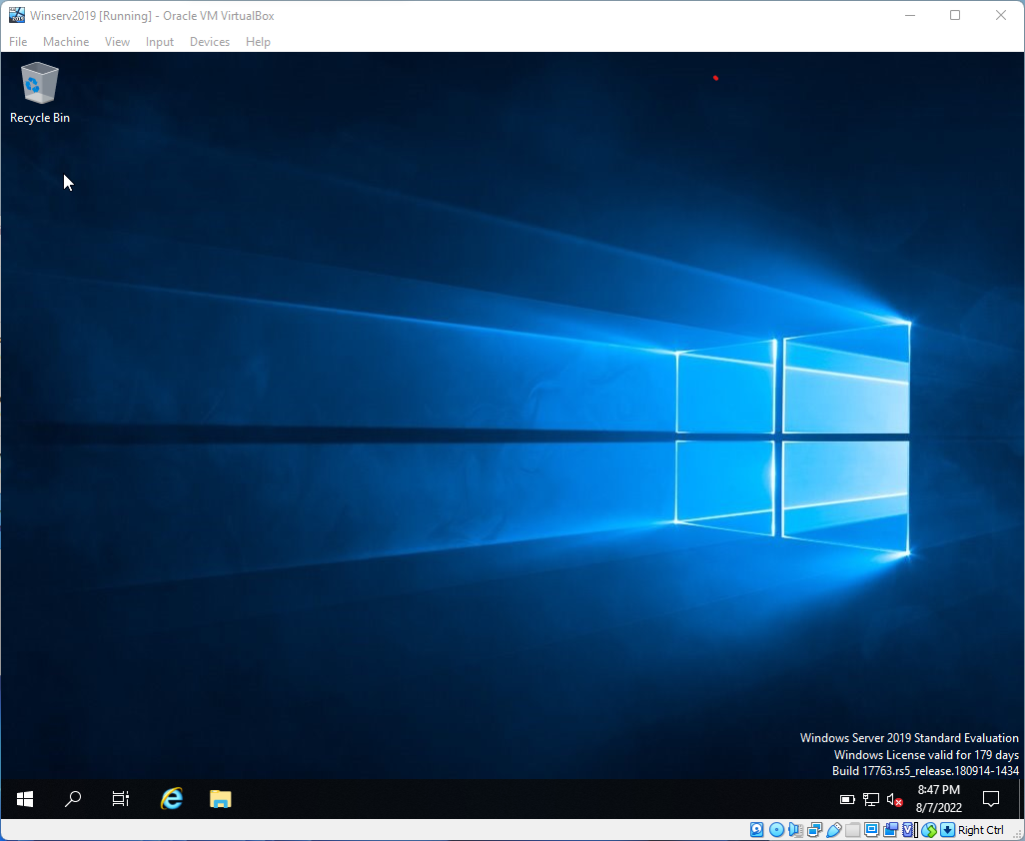

1. Watch video and install Windows 2008 server

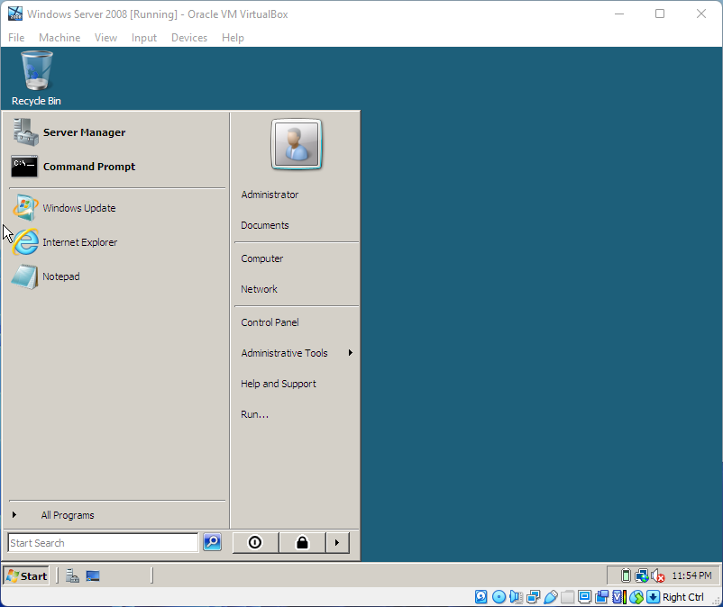

1. The Packet Tracer application downloaded.